



**Batch: B1 Roll No.:160104231119 Experiment No.:4**

**Aim:** Perform On Page SEO Optimization.

**--------------------------------------------------------------------------------------------**

**Resources needed:** Internet, any On Page SEO Optimization tool and MS-office

# Theory:

On-page SEO is the practice of optimizing individual web pages in order to rank higher and earn more relevant traffic in search engines. On-page refers to both the content and HTML source code of a page that can be optimized, as opposed to off-page SEO which refers to links and other external signals.

Before starting the on page optimization, keyword research need to be carried out.

# Steps for Keyword Research

1. Getting started with a brainstorm list
2. Acknowledging that you need a keyword research tool
3. Refining your list using suggested keyword phrases from an analysis tool



1. Verifying keyword phrase relevance
2. Looking at search volume to determine consumer demand
3. Analyzing the competitive space to make sure you and the searcher think the keywords mean the same things, and to decide if the space is too competitive

Once the keywords are finalized then the page can be optimized accordingly**.** Search engines love unique and high-quality original content. If the content of website is only the web pages copied from other websites, most likely it will not be indexed by search engines. In addition, the website content being continually updated is most basic condition for survival and development of a website.

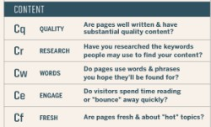Content optimization is based on following factors

Content pages are the meat of websites and are almost always the reason visitors come to a site. Ideal content pages should be very specific to a given topic—usually a product or an object—and be hyper-relevant.

# Title tag

A title tag is an HTML element that specifies the title of a web page. Title tags are displayed on search engine results pages (SERPs) as the clickable headline for a given result, and are important for usability, SEO, and social sharing. The title tag of a web page is meant to be an accurate and concise description of a page's content.

*Best Practices for Creating Titles*

* Here are some best practices you should follow for creating titles on pages:
* Each page should have a unique title.
* If practical, try to include your Primary Keyword Phrase in every title of every page.
* Begin the title of your home page with your Primary Keyword Phrase, followed by your best Secondary Keyword Phrases.
* Use more specific variations to your Primary Keyword Phrase on your specific product, service, or content pages.
* If you must include your company name, put it at the end of the title.
* Use the best form, plural or singular, for your keywords based on what WordTracker says is searched on more often.



* Do not overdo it - do not repeat your keywords more than 2 to 3 times in the title.
* Make sure the <title> tag is the first element in the <head> section of your page - this makes it easier for Google to find the page.

# Meta Description tag

The meta description is a useful meta tag as, very simply, it explains to search engines and (sometimes) searchers themselves what your page is about. Let’s say you were googling the phrase “meta keywords” for example. You might encounter the following results:

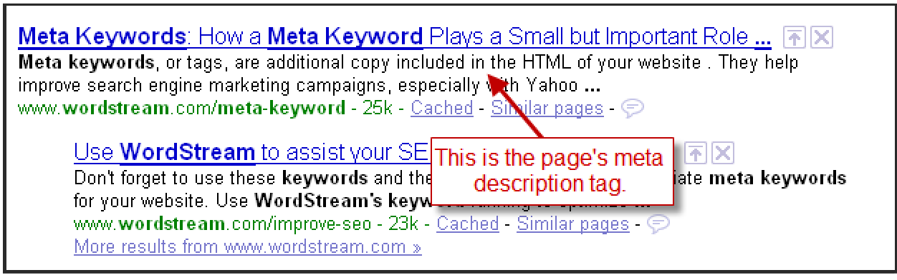

Syntax-

<meta name="description" content="An accurate, keyword-rich description about 150 characters">

*Meta Description Tag Tips*

* Use keywords in your meta description tag.
* Try not to repeat the words overly often, but try to use multiple syntaxes of your key words.
* There should not be more than 150 characters in a description metatag of a single web page.
* Use a different meta description tag for each page, as each page is different and stands a better chance of being found if you place a good title and description on it.

# Meta keyword tag

The Keyword meta tag includes individual keywords separated by commas. Search engine crawlers use the Keyword meta tag information to index the website and display it in the search results. The keywords should be descriptive and optimized to ensure that the search engine displays the website when users search for these specific keywords.

<meta name="keywords" content="Keyword1, Keyword2, Keyword3">

# Meta Robot tag

It explain to a spider of a search engine you only want it to index just the first page of your website or that it is allowed to index the whole website.



Syntax- <meta name="robots" content="selection">

Ex- <meta name="robots" content="index, follow">

* index/noindex - This tells the engines whether to show your page in search results or not.
* follow/nofollow - This tells the engines what to do with links on your pages: whether they should trust and "follow" your links to the next page or not.

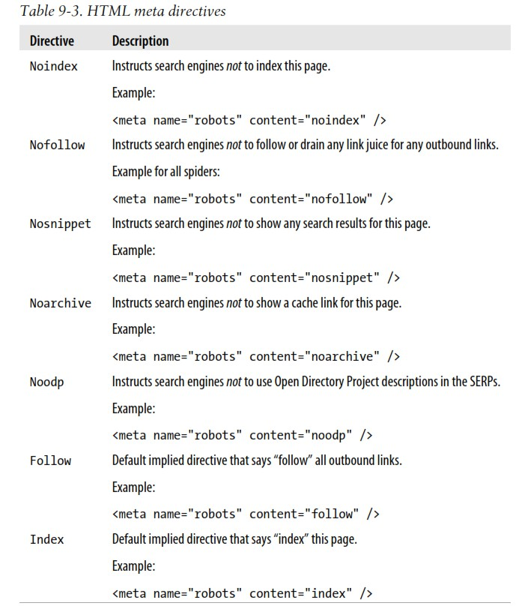

The content of a page is what makes it worthy of a search result position. It is what the user came to see and is thus extremely important to the search engines. As such, it is important to create good content. So what is good content? From an SEO perspective, all good content has two attributes. Good content must supply a demand and must be linkable. Duplicate content can present three main issues for search engines:



* 1. They don't know which version(s) to include/exclude from their indices.
  2. They don't know whether to direct the link metrics (trust, authority, anchor text, link equity, etc.) to one page, or keep it separated between multiple versions.
  3. They don't know which version(s) to rank for query results. Thus content optimization is a major concern from SEO point of view. **Heading Tag optimization instructions**
  4. Never miss the H1 tag on a page as the search spiders tend to look for h1 tags to get the idea about the content of the page.
  5. Don't overuse H1 tag, i.e. it should be only one for each page.
  6. Use targeted keywords or phrases in the headings; avoid words that are not relevant to the

\======page.

* 1. Use targeted keywords in the beginning of the headings.
  2. The headings should be followed by a body of relevant content.
  3. Maintain the order of heading tags; H1 should come first in the page then H2, H3 and so on.

# Images and Alt Text

**<img** src="seo/images/images-and-alt-text1.png" alt="SEO Images and alt text 1"**/>**

* + - If an image fails to load or does not render on a page due to any reason then alt tag will appear to tell what the image is about. It helps users understand what kind of image was there.
    - The search engines are designed to understand text on pages, not for the images. So, if your image is accompanied with alt tag the search engine will know from the alt tag what the image is showing and it will provide right images to the users.
    - You can include your main keywords in the alt tag if they are related to the image. It will improve your image search ranking for that keyword.



# Anchor text and link title

* + - Anchor text is the visible characters and words that hyperlinks display when linking to another document or location on the web.
    - link TITLE is supposed to provide additional / advisory information about the link(expand on the meaning of the link).
    - The anchor text is supposed to “name” the link, while the title text provides information about where the link will send the user. (especially with “click here” and “more” anchor text).

.

# Procedure:

1. **Perform on page SEO using online tools for any one pages of your own website and prepare report considering the following points. format.**
   * Keyword Optimization
   * Title tag
   * Meta description tag
   * Meta keyword tag
   * Meta robot tag
   * Heading tag
   * Anchor text
   * Link title
   * Alt Text in img tag

# Results:

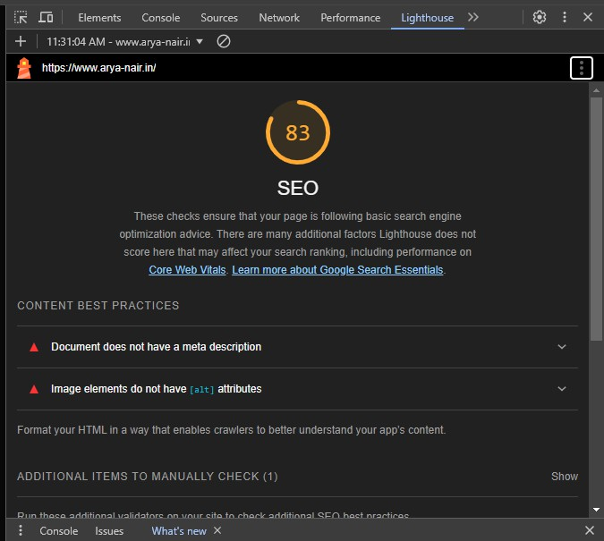Using google lighthouse tool for SEO score calculation



this is the score i get for my personal website

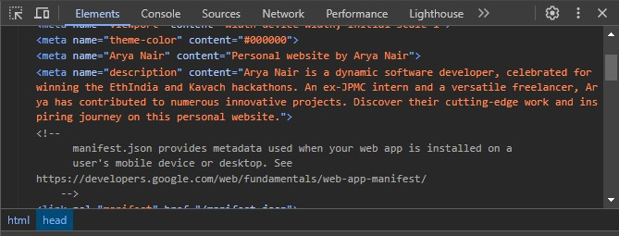

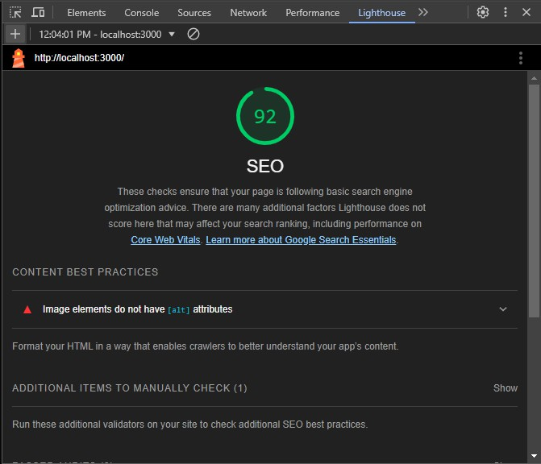add meta tag description



score improved after adding meta tags

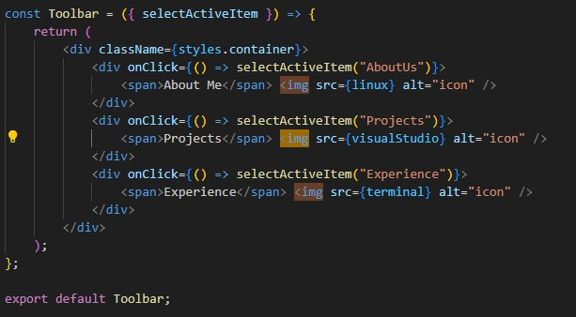

add alt tags to the all the img tags in the codebase



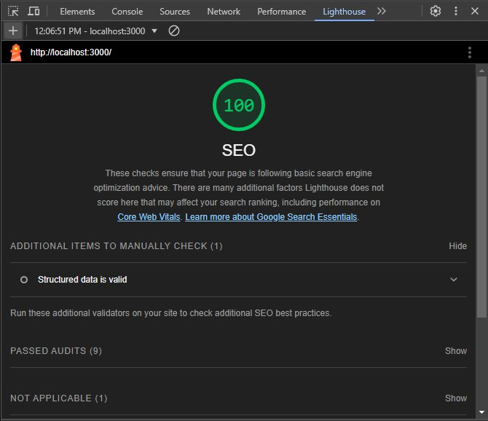

after adding alt tags



# Questions:

Explain off page SEO.

Off-page SEO involves actions taken outside of your website to impact your rankings within search engine results pages. Major elements include:

1. Backlinks: Acquiring links from other reputable sites to boost credibility and authority.
2. Social Media: Using social platforms to increase content visibility and engage with a wider audience.
3. Guest Blogging: Writing for other blogs to gain exposure and backlinks.
4. Influencer Outreach: Collaborating with influencers to reach broader audiences.
5. Local SEO: Optimizing for local search results by managing local listings and gathering reviews.
6. Brand Mentions: Getting your brand mentioned on other websites, with or without links. These efforts help improve your site&#39;s perceived relevance, trustworthiness, and authority, crucial for better search rankings.

# Outcomes:

CO2 Understanding search engine optimization essentials

# Conclusion: (Conclusion to be based on the objectives and outcomes achieved)

Improvised SEO of my personal website using google lighthouse

**Grade: AA / AB / BB / BC / CC / CD /DD**

**Signature of faculty in-charge with date**



**References:**

* 1. Eric Greenberg, Alexander Kates, “Strategic Digital Marketing: Top Digital Experts Share the Formula for Tangible Returns on Your Marketing Investments” McGraw Hill Education 1st edition, 16 August 2013.
  2. Jan Zimmerman “Web Marketing For Dummies” Willy Publishing 3rd Edition, 2011.
  3. Jan Zimmerman, Deborah Ng, “ Social Media Marketing All-in-One For Dummies” Willy Publishing 4th Edition, 2017.
  4. Eric Enge, Stephan Spencer, Jessie Stricchiola, Rand Fishkin, “The Art of SEO”, 2nd Edition Mastering Search Engine Optimization O'Reilly Media 2nd Edition, 2012
  5. John I Jerkovic, “SEO Warriors” O'Reilly Media 1st edition, 2009